Sensor-to-Edge Data Architecture
This document describes the data architecture and communication interface between the STM32N6 microcontroller-based sensing system and the NVIDIA Orin NX edge AI processor.

The system is designed to collect data from multiple sensing modalities, process and structure the data at the microcontroller level, transmit the processed sensor data through a Wi-Fi communication interface, and perform edge AI inference to compute quality attributes such as freshness, aroma, spoilage risk, and other product characteristics.
The system consists of three major processing layers:
Layer | Component | Function
Sensing Layer | Sensors (CH0–CH6) | Collect environmental, chemical, visual, and physical signals
Embedded Layer | STM32N6 MCU | Sensor acquisition, sampling, preprocessing, aggregation
Edge AI Layer | NVIDIA Orin NX | Sensor fusion, AI inference, quality evaluation

The system follows a distributed processing model:

STM32N6 Responsibilities

Sensor acquisition

Sampling

Basic preprocessing

Data aggregation

Feature preparation

Wireless transmission

Orin NX Responsibilities

Sensor fusion

AI model inference

Quality attribute computation

Data storage and analytics

Sensor Data Collection
Channel | Sensor | Data Collected / Output
CH0 | 2 kg Straight-Bar Load Cell | Force / Weight measurement
CH0 | MCU ADC Input / Interface | Analog voltage signals from sensors
CH1 | Sensirion SGP41 VOC/NOx Module | VOC Index, NOx Index, raw gas signal
CH1 | Bosch BME688 Module | Gas resistance, temperature, humidity, pressure
CH1 | Figaro TGS2602 VOC / Odor Sensor | Gas resistance, odor intensity response
CH1 | Renesas ZMOD4410 | Total VOC concentration, IAQ index, gas resistance
CH2a | Sensirion SCD41 CO₂ Sensor | CO₂ concentration, temperature, humidity
CH2a | MQ-136 Sulfur Gas Sensor | Hydrogen sulfide (H₂S) proxy concentration, sensor resistance
CH2a | MQ-135 Gas Sensor | Ammonia (NH₃) proxy, NOx proxy, alcohol vapors, benzene/smoke proxy
CH2a | Ethylene Electrochemical Sensor | Ethylene concentration, electrochemical current
CH2b | Figaro TGS2600 Air Contaminants Sensor | Hydrogen proxy, air contaminant concentration, sensor resistance
CH2b | PID VOC Module | Total VOC concentration, ionization current
CH3 | Sensirion SHT45 RH/T Sensor | Temperature, relative humidity
CH3 | MPXV7002DP Differential Pressure Sensor | Differential pressure, airflow estimation
CH4 | PMS7003 PM Sensor | PM1, PM2.5, PM10 concentrations, particle count
CH4 | Sensirion SPS30 PM Sensor | PM1, PM2.5, PM4, PM10 mass concentration, particle number concentration
CH5 | OV9281 Global-Shutter Camera | Image frames, shape, texture, color/visual features
CH5 | Fixed LED Illumination Set | Controlled illumination level for image capture
CH6 | AS7341 Spectral Sensor | Multi-band visible spectral intensities
CH6 | AS7265x Triad Spectroscopy Module | 18-band spectral reflectance measurements
CH7 | 5 kg Load Cell + HX711 Kit | Weight, load cell voltage signal
CH7 | MPU6050 / Vibration Sensor | Acceleration (X,Y,Z), angular velocity
CH8 | INA219 Current / Power Monitor | Voltage, current, power consumption
CH8 | DS18B20 Temperature Probe | Temperature
CH8 | Reed Switch Module | Door/chamber open–close status
CH8 | SFM3003 Flow Sensor | Airflow rate
CH8 | 12V 1/8” NC Solenoid Valve | Airflow control state (open/close)
CH8 | 12V Diaphragm Pump | Air sampling flow generation
CH8 | Pump / Valve Driver Electronics | Actuator control signals
CH9 | INMP441 I²S MEMS Microphone | Acoustic signal / chamber sound
CH9 | VL53L1X ToF Sensor | Distance / fill-height measurement

Sensors Grouped by Sensor Type
Sensor Modality | Sensors Included | Data Collected | Aggregated Data Sent to Edge  (Parameters)
VOC sensing | SGP41, ZMOD4410, BME688, TGS2602, | VOC index, NOx index, total VOC concentration, ionization current | VOC_vector
MOS/MOX gas sensing | MQ135, MQ136, TGS2600,SCD41 (CO₂) | Gas resistance, odor response, ammonia proxy, sulfur proxy, air contaminant levels | MOS_vector
Electrochemical sensing | Ethylene EC sensor | Ethylene gas concentration, electrochemical current | EC_vector
Selective gas sensing | SCD41 (CO₂) | CO₂ concentration, temperature, humidity | EC_vector / Gas_vector
Environmental sensing | SHT45, DS18B20 | Temperature, humidity | ENV_vector
Airflow / pressure sensing | MPXV7002DP, SFM3003 | Differential pressure, airflow rate | ENV_vector
Particulate sensing | PMS7003, SPS30 | PM1, PM2.5, PM4, PM10 concentrations, particle count | PM_vector
Spectral sensing | AS7341, AS7265x | Multi-band spectral intensities, reflectance spectrum | SPECTRAL_vector
Vision sensing | OV9281 | Image frames, color, texture, object shape | VISION_data
Physical sensing | Load cells | Weight / force measurements | PHYSICAL_data
Motion sensing | MPU6050 | Acceleration, angular velocity | PHYSICAL_data
Platform health sensing | INA219 | Voltage, current, power consumption | SYSTEM_health_vector
Distance sensing | VL53L1X | Distance / fill height measurement | PHYSICAL_data
Acoustic sensing | INMP441 | Acoustic signal / sound profile | AUDIO_data

MCU to Edge data transmission

​​ 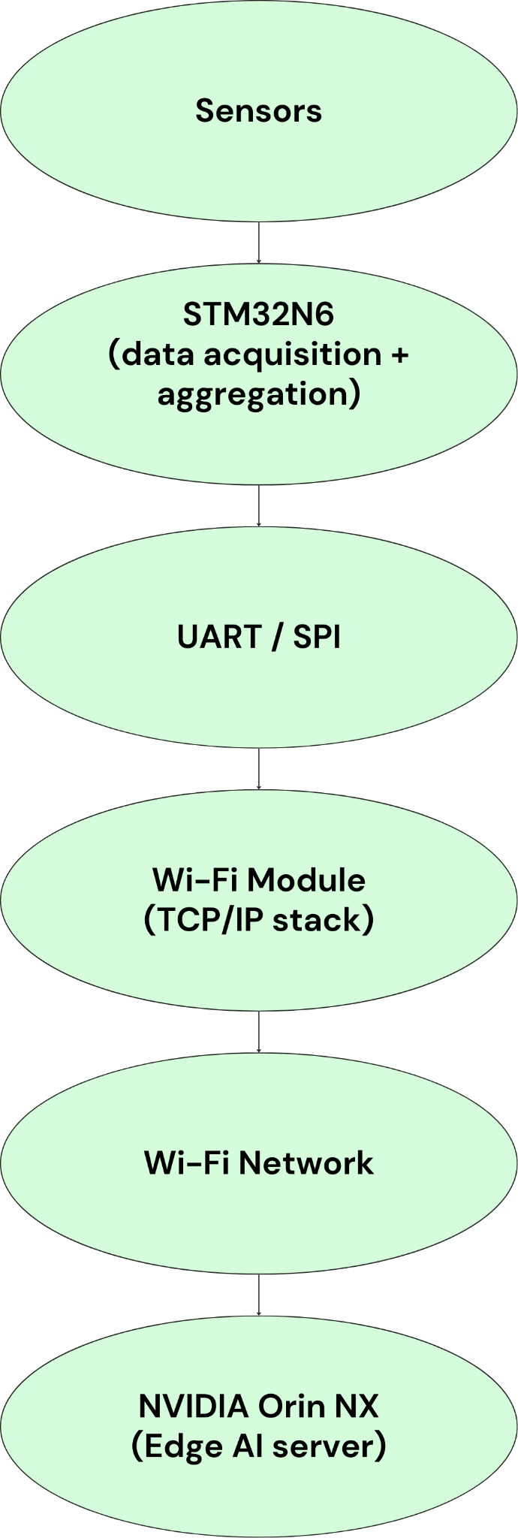

Communication protocols that can be used:
Protocol | Use case
MQTT | best for sensor streaming
TCP socket | simple direct connection
HTTP REST | request-response
UDP | low latency
Mostly we will be going with MQTT
Data Reception on Orin NX
The Orin NX runs a server application
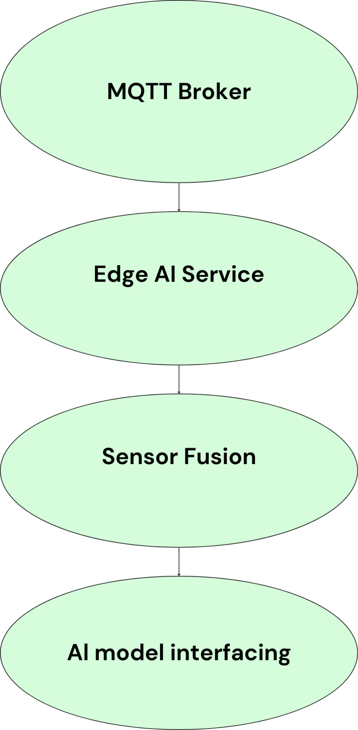

Example:-
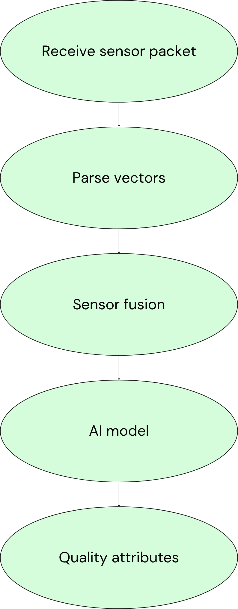
The MCU will not only send sensor data, but also receive control commands from the Edge through the Wi-Fi module.
Instead of hardcoding the sampling period in STM32 firmware, the Edge AI system sends configuration commands such as:
- sampling period
- sensor enable/disable
- sampling window size
- start/stop acquisition
We will be using MQTT protocol for both side
Direction | Topic | Purpose
STM32 → Edge | mxsense/device01/data | sensor data
Edge → STM32 | mxsense/device01/control | commands
Json that we will be sending to edge from stm32n6
{
"header": {
"device_id": "MX-ORIN-NX-001",
"timestamp": "2026-03-17T02:05:00Z",
"firmware_version": "2.1.0-stable",
"location_tag": "Factory-Floor-A"
},

"mcu_monitoring": {
"carrier_board_mcu": "STM32-H7",
"uptime_seconds": 86400,
"vcc_main_v": 12.05,
"i2c_bus_status": "OK",
"spi_bus_status": "OK",
"watchdog_resets": 0
},

"device_health": {
"soc_temp_c": 45.5,
"gpu_load_percent": 62.0,
"cpu_load_percent": [15, 22, 10, 12, 18, 14],
"ram_usage_mb": 4102,
"emmc_storage_free_gb": 14.2,
"power_mode": "15W_6CORE",
"fan_speed_rpm": 2200
},

"sensor_payload": {

"env": {
"sht45_temperature": 0.0,
"sht45_humidity": 0.0,
"bme688_temperature": 0.0,
"bme688_humidity": 0.0,
"bme688_pressure": 0.0
},

"voc": {
"sgp41_voc_index": 0,
"sgp41_nox_index": 0,
"zmod4410_voc_concentration": 0.0,
"bme688_gas_resistance": 0.0,
"tgs2602_odor_level": 0.0
},

"gas": {
"mq135_air_quality": 0.0,
"mq136_sulfur_level": 0.0,
"tgs2600_contamination": 0.0,
"ethylene_sensor_value": 0.0
},

"pm": {
"pms7003_pm1": 0.0,
"pms7003_pm2_5": 0.0,
"pms7003_pm10": 0.0,
"sps30_pm1": 0.0,
"sps30_pm2_5": 0.0,
"sps30_pm10": 0.0
},

"spectral": {
"as7341_channels": [],
"as7265x_channels": []
},

"force": {
"loadcell_2kg_force": 0.0,
"loadcell_5kg_force": 0.0
},

"flow": {
"mpxv7002dp_pressure_diff": 0.0,
"sfm3003_flow_rate": 0.0
},

"system": {
"ds18b20_temperature": 0.0,
"ina219_current": 0.0,
"ina219_power": 0.0,
"reed_switch_state": false
},

"acoustic": {
"inmp441_noise_level": 0.0
},

"distance": {
"vl53l1x_fill_height": 0.0
}
},

"image_metadata": {
"camera_id": "CSI-01",
"frame_id": 98442,
"resolution": "1920x1080",
"format": "JPEG",
"storage_path": "/opt/mxsense/data/img/98442.jpg",
"inference_applied": true,
"detected_objects": []
}
}
*approx
Json that we will be sending to stm32n6 from edge in order to control different sensors
{
"header": {
"device_id": "stm32_01",
"timestamp": "2026-03-17T10:35:00Z",
"command_id": "cmd_001"
},

"mode_control": {
"operation_mode": "sampling"
},

"sampling_config": {
"global_interval_ms": 1000,

"env_interval_ms": 1000,
"voc_interval_ms": 2000,
"gas_interval_ms": 2000,
"pm_interval_ms": 5000,
"spectral_interval_ms": 10000,
"vision_interval_ms": 20000
},

"sensor_control": {
"sgp41_enabled": true,
"bme688_enabled": true,
"zmod4410_enabled": true,
"tgs2602_enabled": true,
"mq135_enabled": true,
"mq136_enabled": true,
"tgs2600_enabled": true,
"sps30_enabled": true,
"pms7003_enabled": false,
"as7341_enabled": true,
"as7265x_enabled": false,
"camera_enabled": true
},

"actuator_control": {
"pump_state": true,
"valve_state": false,
"purge_duration_ms": 5000
},

"calibration": {
"zero_calibration": false,
"span_calibration": false
}
}
Basically we will be sending in this way
STM32 → (sensor JSON) → Orin
Orin → (control JSON) → STM32
DATABASE SCHEMA DESIGN
STM32 → Orin (raw) → Orin processing → Backend API → Database
Data storage pipeline
Step 1: Data Acquisition (STM32 → Orin)
- STM32 collects high-frequency raw sensor data (100 ms – 1 s).
- Data is transmitted to Orin in structured JSON format.
- Data is stored temporarily in edge memory (buffer).

Step 2: Edge Processing (Orin)
- Perform feature extraction:
  - Example: Average, min, max, standard deviation
  - Trends (increasing/decreasing)
- Perform data aggregation:
  - Multiple raw samples → single summarized record
- Perform anomaly detection:
  - Identify abnormal patterns or threshold violations

Step 3: Data Segregation
Orin generates three types of outputs:

3.1 Processed Data (Primary)
- Aggregated and meaningful features
- Used for dashboards and analytics

3.2 Sampled Raw Data (Secondary)
- Downsampled sensor readings (e.g., every 1–5 seconds)
- Used for plotting graphs

3.3 Alerts / Events
- Generated on anomalies or threshold breaches
- Includes severity and type

Step 4: Data Transmission (Orin → Backend)
- Data is sent to backend via:
  - REST API or MQTT(to be decided)
- Separate endpoints for:
  - Processed data
  - Sampled data
  - Alerts

Step 5: Backend Processing
- Validate incoming data
- Attach metadata (timestamps, device ID if required)
- Route data to appropriate database tables

Step 6: Data Storage (Database)
Data is stored in three main tables:
- Processed Data Table
  - Stores aggregated features and scores
- Sampled Sensor Data Table
  - Stores downsampled readings for visualization
- Alerts Table
  - Stores anomaly and event information

Step 7: Data Retention Strategy
- Raw data (Edge): Short-term (buffer only)
- Sampled data: Medium-term (days/weeks)
- Processed data: Long-term (analytics and reporting)

Database Creation on AWS (Amazon RDS – PostgreSQL)

Overview
The cloud database is deployed using Amazon RDS (Relational Database Service) with PostgreSQL.
This provides a managed, scalable, and secure relational database for storing processed and sampled sensor data.
Step 1: Access AWS RDS
- Log in to AWS Console
- Navigate to RDS Dashboard
- Click on “Create Database”

Step 2: Select Database Engine
- Engine type: PostgreSQL
- Version: Latest stable version (default)
Step 3: Choose Deployment Type
- Template: Free Tier / Dev-Test
- DB Instance Class: db.t3.micro (cost-efficient)
Step 4: Configure Database Settings
- DB Instance Identifier: mxsense-db
- Master Username: postgres
- Password: (securely configured)
- Initial Database Name: mxsense
Step 5: Configure Storage
- Storage Type: General Purpose (gp2/gp3)
- Allocated Storage: 20 GB (default)
Step 6: Configure Connectivity
- Virtual Private Cloud (VPC): Default
- Public Access: Enabled (for development)
- Security Group: Default (updated in next step)
Step 7: Create Database Instance
- Click “Create Database”
- Wait for the instance status to become Available
Step 8: Configure Network Access
- Navigate to Connectivity & Security
- Open the associated VPC Security Group
- Add inbound rule:
  - Type: PostgreSQL
  - Port: 5432
  - Source: 0.0.0.0/0 (for development only)
Step 9: Connect to Database
Use a database client (pgAdmin, DBeaver, etc.) with:
- Host: <RDS Endpoint>
- Port: 5432
- Username: postgres
- Password: <configured password>
- Database: mxsense
Step 10: Initialize Database Schema
- Execute the SQL schema scripts:
  - devices
  - processed_data
  - sampled_sensor_data
  - alerts
  - image_metadata
Step 11: Verify Setup
- Insert test data into tables
- Run queries to confirm successful setup

